Game Design Document

Fill up the following document

1. Write the title of your project.

Galactic Adventure

1. What is the goal of the game?

To complete all of the stages with friends.

1. Write a brief story of your game.

The players are out in space you can choose who you want to be and you are stranded in deep space trying to get back to earth with your friends and aliens and asteroids block your path blast through the aliens and dodge the asteroids to get to earth but be careful you need fuel.

1. Which are the playing characters of this game?

* Playing characters are the ones who respond to the user based on the input from the user.
* Cars, monkeys, dinos, wizards, etc., are the playing characters in the game.

|  |  |  |
| --- | --- | --- |
| Number | Character Name | What can this character do? |
| 1 | Heloro | Can heal team-mates |
| 2 | Polly | Can protect Team-mates |
| 3 | Zechum | Attacks the aliens |
| 4 | Eldor | Has a radar which can see asteroids from far away and fuel. |
| 5 |  |  |
| 6 |  |  |
| 7 |  |  |
| 8 |  |  |

1. Which are the Non-Playing Characters of this game?

* Non-Playing characters are the ones that don't have an action or behavior when the user interacts with the game.
* Hurdles, stones, bananas, coins, etc., are non-playing characters in the game.

|  |  |  |
| --- | --- | --- |
| Number | Character Name | What can this character do? |
| 1 | Fuel | Gives the spaceships fuel |
| 2 | Asteroids | Blocks player (like a wall) |
| 3 | Aliens | Attacks the player with plasma |
| 4 | Missile | Attacks the aliens |
| 5 | Plasma | Hits teammates dealing damage |
| 6 |  |  |
| 7 |  |  |
| 8 |  |  |

Draw your imagination of this game. What does this game look like?

* Draw the game either on your computer or on paper.
* Add images of the game scenes to show each of the playing and non-playing characters at least once. 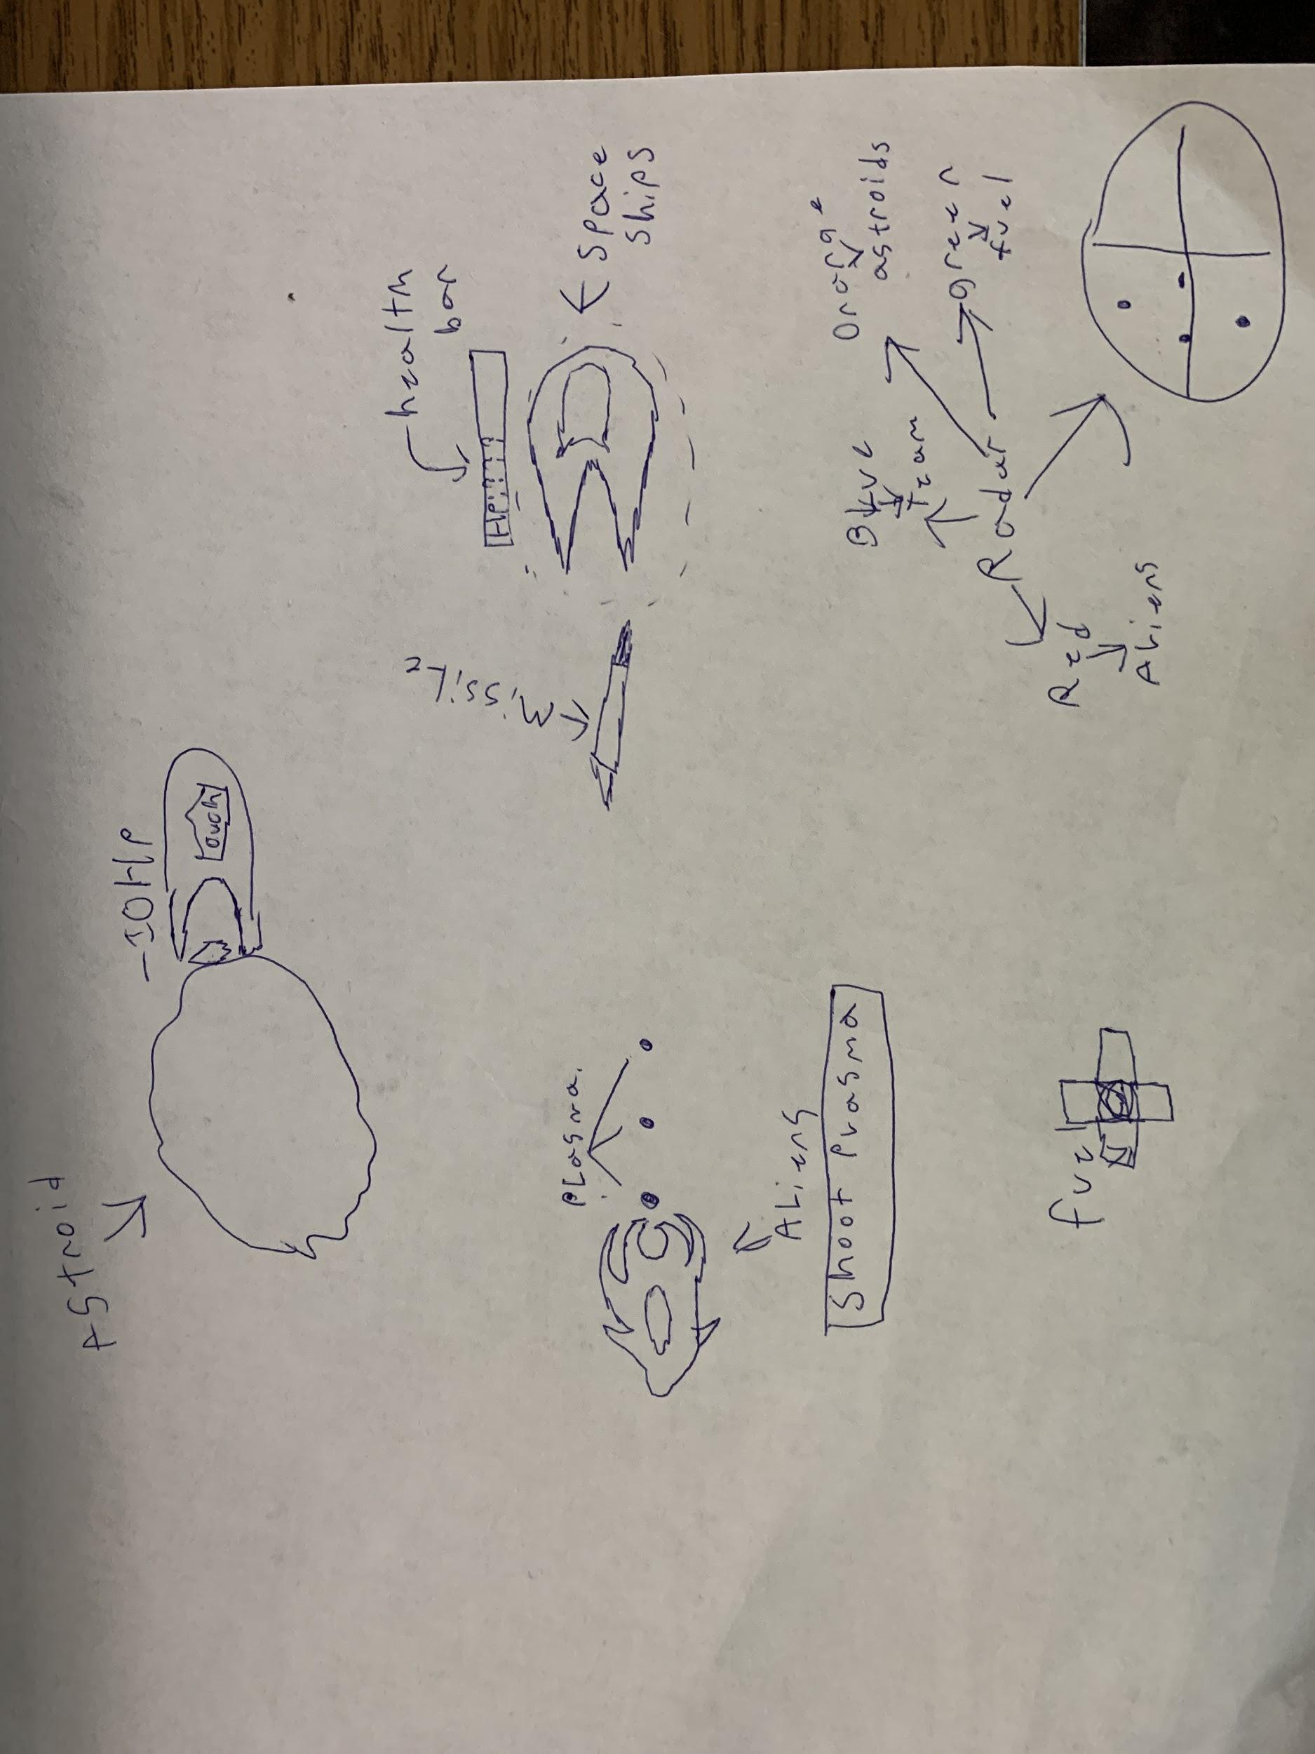

How do you plan to make your game engaging?

There will be a rating based on how fast you make it thru each stage say if you make it thru a stage in 3 minutes they will get one star for being to slow and 2 starts for making it somewhat thu fast